Belmont City College
Semester 1 Examination, 2012
Question/Answer Booklet

PHYSICS
Stage 2 2012
Name: ___________________________________
Teacher: ___________________________________

Time allowed for this paper
Reading time before commencing work: Ten minutes
Working time for paper: Two and a half hours
Material required/recommended for this paper
To be provided by the supervisor
This Question/Answer Booklet
Physics Formulae, Constants and Data Sheet
To be provided by the candidate
Standard Items: Pens, pencil, eraser, correction fluid, ruler, highlighter
Special Items: MATHOMAT and/or Mathaid, drawing compass, protractor, set square and calculators satisfying the conditions set by the Curriculum Council for this subject.
Important note to candidates
No other items may be taken into the examination room. It is your responsibility to ensure that you do not have any unauthorised notes or other items of a non-personal nature in the examination room. If you have any unauthorised material with you, hand it to the supervisor before reading any further.
Structure of this paper

Section | Number of questions | Suggested Time (minutes) | Number of questions to be answered | Marks available | Percentage of exam
A: Short Answers | 12 | 58 | ALL | 53 | 42
B: Problem Solving | 5 | 70 | ALL | 57 | 46
C: Comprehension and Data Analysis | 1 | 22 | ALL | 15 | 12
 |  |  | Total | 125 | 100%
Instructions to candidates
- The rules for the conduct of Western Australian external examinations are detailed in the Year 12 Information Handbook 2010. Sitting this examination implies that you agree to abide by these rules.
- Write your answers in this Question/Answer Booklet.
- Working or reasoning should be shown clearly when calculating or estimating answers.
- You must be careful to confine your responses to the specific questions asked and to follow any instructions that are specific to a particular question.
- Spare pages (p29-32) are included at the end of this booklet. They can be used for planning your responses and/or as additional space if required to continue an answer.
- Planning: If you use the spare pages for planning, indicate this clearly at the top of the page.
- Continuing an answer: If you need to use the space to continue an answer, indicate in the original answer space where the answer is continued, i.e. give the page number.
Fill in the number of the question(s) that you are continuing to answer at the top of the page.

Section One: Short answers 41% (53 Marks)
This section has twelve (12) questions. Answer all questions. Write your answers in the space provided.
Suggested working time: 55 minutes
_________________________________________________________________________
1. Why is there a rule that university research students are never allowed to eat or drink in a Science laboratory where radioactive isotopes are being used? [3 marks]
______________________________________________________________________________________________________________________________________________________________________________________________________________________________________________________________________________________________________________________________________________________________________________________________________________________________________________________

2. (3 marks)

Identify “X” in each of the following equations and place its symbol in the brackets to the right of the equation. Name what is produce and if a type of radiation, name the radiation not the particle.

a. 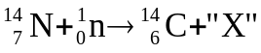 [ ] __________________________

b. 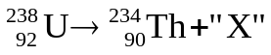 [ ] __________________________

c. 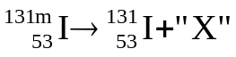 [ ] __________________________

(note: m denotes in excited state)
3. The diagram below shows part of the decay series for radon 222. The half lives of radon and subsequent daughters is also shown. Use the decay series to write balanced nuclear equations for the following decays:
[4 marks]
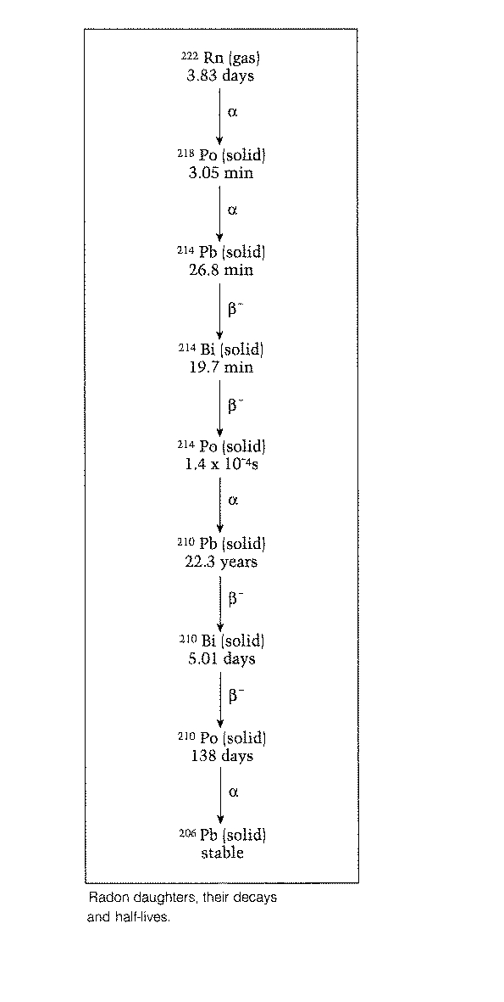
(a) Bi 210 decaying to Po – 210

(b) Po 210 decaying to Pb - 206

4. For an atomic bomb to explode the amount of uranium-235 must reach critical mass and then the fission reaction created from a neutron induced chain reaction becomes uncontrollable. What is a neutron induced chain reaction and why does it need critical mass to explode? [3 marks]
_________________________________________________________________________
_________________________________________________________________________
_________________________________________________________________________
_________________________________________________________________________
5. a) An atom of helium-4 is made up of 2 protons and 2 neutrons in its nucleus.
The mass of the 2 protons and 2 neutrons, compared with the mass of the helium-4 nucleus would be: (circle the correct answer)

Greater than the nucleus

Less than the nucleus

Same as the nucleus
[1 mark]

b) Explain your answer to part a). [3 marks]
________________________________________________________________________________________________________________________________________________________________________________________________________________________________________________________________________________________________________________________________________________________________________________________________________________________________________________________________________________________________________________________________________________________________________________________________________
6. a) A car of mass 1.50 x10³ kg is at rest when the driver accelerates so that the impulse produced by the engine is 2.00 x 10 ⁴ Ns. What would be the value of the velocity of the car after this initial acceleration? [3 marks]

b) Calculate the kinetic energy of the car after the impulse from the engine has been applied. (If you couldn’t do part a of this question, use a value of 12.0 ms⁻¹ for the car’s velocity). [2 marks]

7. In a football match, a player kicks a stationary football of mass 0.440 kg and gives it a speed of 32.0 m s^{–1}.
a) The contact time between the football and the footballer’s boot was 9.20 ms. Calculate the average force of impact on the football.
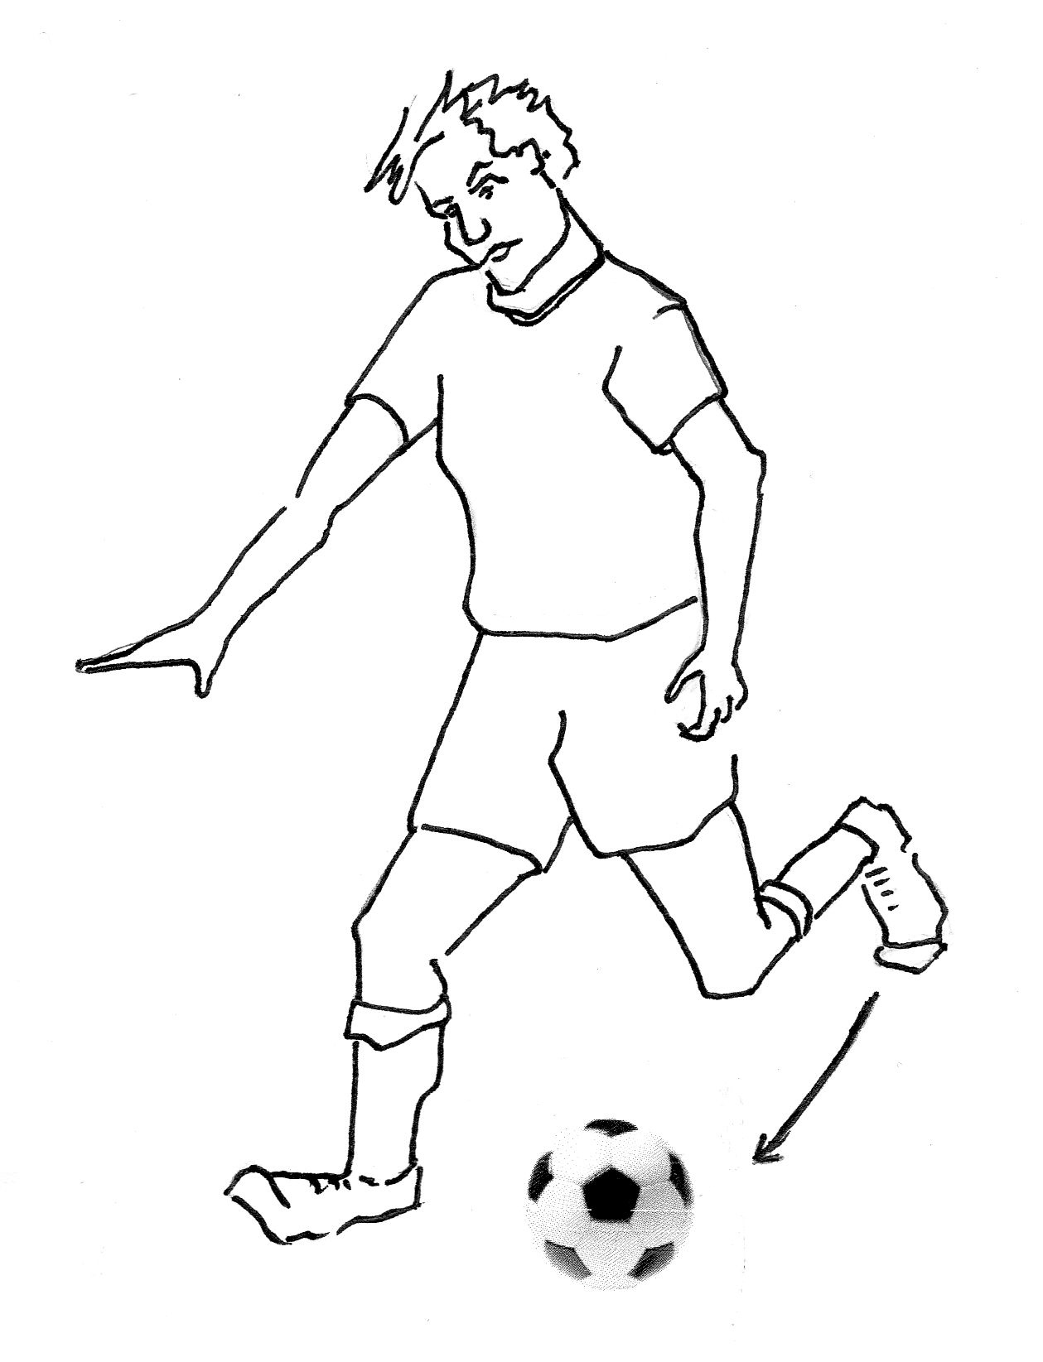
[2 marks]

b) A video recording showed that the toe of the boot was moving along the straight line of the impact force when it struck the football. The force of the impact slowed the 1.60 kg boot down from a speed of 24 m s^{–1} to a speed of 15 m s^{–1}. Calculate the change of momentum of the boot. [2 marks]

8. World champion 200 metre bicycle sprinters can develop enormous power in their legs whilst maintaining a top speed of around 78.0 km h⁻¹.
a) If a 70.0 kg rider maintains a constant force on his bike from his legs of 1.25 x 10² N over the whole 200 m track at a speed of 78.0 km h⁻¹, calculate a value for the power output of his legs. [2 marks]

b) Draw and label all the vectors representing the forces acting on the cyclist below when moving at a constant velocity. [4 marks]


9. In a game of football, a ball travelling at 5.00 m s⁻¹ struck the moving head of a player and rebounded at 6.00 m s⁻¹ into the goal. The angle between the initial and final directions of the ball was 90º.

40º
50º
a) Calculate the change in velocity of the ball. [3 marks]

b) The mass of the ball is 3.50 x10² g and it was in contact with the player’s head for 0.200s, during which time its change in velocity was 7.50 m s⁻¹. Calculate the magnitude of the force that the ball exerted on the head of the player during contact time. [3 marks]

10. a). The elastic of a child’s crossbow is pulled back and held firmly so that it makes an angle of 45.0º with the tail of the arrow. If the tension in each side of the elastic is 65.0 N, (assume a constant value) calculate the total force acting on the arrow at the instant it is released. Give the force’s direction. [3 marks]
45º
45º

Arrow tail

b) If the arrow has a mass of 0.250kg and the acceleration of the arrow by the elastic takes place over a distance of 15.0 cm before leaving the crossbow, calculate the maximum velocity attained by the arrow. (If you couldn’t do part a of this question, use a value of 80.0 N for net force). [2 marks]


11. A truck driver on the top of a hill releases the hand brake whilst in neutral gear, so that the truck rolls 100 m down the hill to a level emergency sand track. The hill has a slope of 25.0º to the horizontal and the truck’s mass is 6.50 tonnes.
Emergency sand track
25⁰
100 m

a) Calculate the speed of the truck at the bottom of the hill. [3 marks]

When the driver reaches the bottom he realizes that his brakes have failed, but luckily there is an emergency track made of sand which has been made to stop runaway trucks coming down the hill.
b) If the sand in the emergency track has a resistive force of 55.0 kN against the wheels of the truck, calculate the distance the truck travels in the sand (in the horizontal direction) before it stops. (If you couldn’t do part a of this question, use a value of 30.0 m s⁻¹ for the truck’s velocity). [3 marks]

12. The graph below shows how the displacement of a toy train moving in a straight line varies over a period of time.
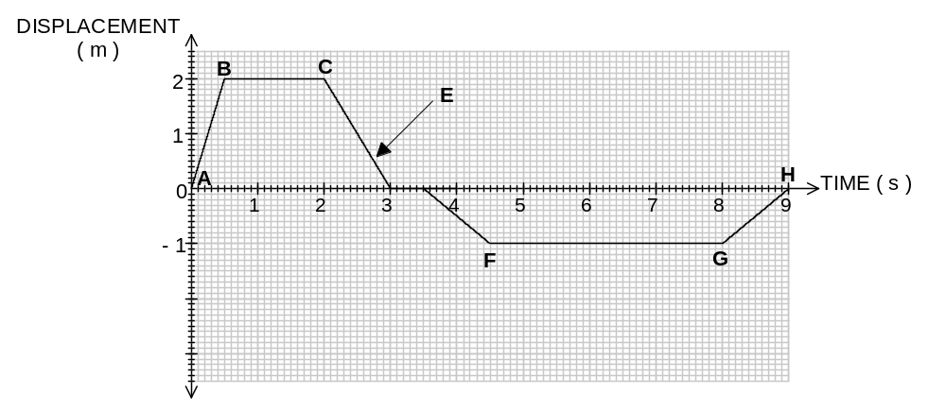
Seconds
a) What is the maximum speed attained by the train?

Answer: ________________ [1 mark]

b) Describe the motion of the train in section
(i) BC _____________________________________________________

(ii) E ______________________________________________________ [2 marks]

c) What is the total length of track used by the toy train in the above journey as shown by the graph?

Answer: ________________ [1 mark]

END OF SECTION 1
Section Two: Problem-solving 48%(62 marks)
This section has four (4) questions. Answer all questions. Write your answers in the spaces provided.
Suggested working time: 70 minutes
_____________________________________________________________________________________________________________
13. (8 marks total)

a) Melinda likes playing cricket for her school. During a school match, she swings her new 2.20 kg bat forward to strike a 0.350 kg ball that is being bowled towards her at 22.5 ms⁻¹. Her bat is moving towards the ball at a speed of 8.50 ms⁻¹ before it strikes the ball and the bat slows to a speed of 0.300 ms⁻¹ forwards after the ball has been hit.
Calculate the speed with which the ball leaves the bat after it has been hit. [3 marks]


8.50 m s⁻¹
22.5 m s⁻¹

b) Jim has a mass of 55.0 kg and jumps down from his garden wall 2.00 m high onto the ground landing safely by bending his knees. What is Jim’s momentum just before he lands? [3 marks]

c) Explain, in terms of physics, how bending his knees makes the force acting on him smaller whilst his change in momentum remains the same. [2 marks]

14. (16 marks total)
(a) In a thermal nuclear reactor, induced fission is caused by the U–235 nucleus capturing a neutron, undergoing fission and producing more neutrons. Which one of the following statements is true? (Circle the correct answer).

A To sustain the reaction a large number of neutrons is required per fission.
B The purpose of the moderator is to absorb all the heat produced.
C The neutrons required for induced fission of U–235 should be slow neutrons.
D The purpose of the control rods is to slow down neutrons to thermal speeds.
[1 mark]

(b) An unstable isotope of uranium may split into a caesium nucleus, a rubidium nucleus and some neutrons in the following process.

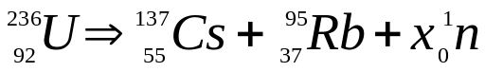

(i) Determine the value of X, that is, the number of neutrons produced in the above process.
[1 mark]
(ii) Calculate the energy, in Mev and in Joules, which is released in the above process, given the following nuclear masses together with data from the Formula and Constants Sheet. [5 marks]
Mass of a neutron = 1.00867 u
mass of a nucleus of Cs 137 = 136.87688 u
mass of a nucleus of Rb 95 = 94.19481 u
mass of a nucleus of U 236 = 235.8055 u

(iii) If the energy released is shared equally by the neutrons as kinetic energy, at what speed do they travel upon emission? [2 marks]

(c) A radioactive source is used to test the thickness of paper. The source is put on one side of the paper and the Geiger counter on the other side. The paper travels from the papermaking plant through the rollers as shown.
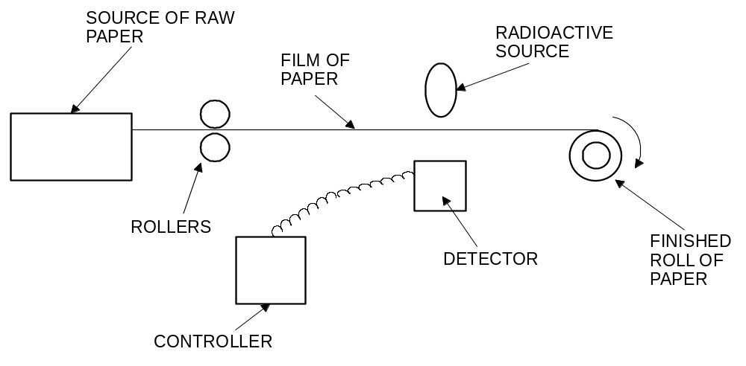
PAPER MAKING PLANT

GEIGER COUNTER

(i) Why are beta particles more suitable than alpha particles or gamma rays for this job? [2 marks]

The table shows the reading on the counter during 70 s.

times in seconds | 10 | 20 | 30 | 40 | 50 | 60 | 70
total count since the start | 50 | 100 | 150 | 195 | 235 | 275 | 315
count in 10 seconds | 50 | 50 | 50 | 45 | 40 | 40 | 40
(ii) Look at the table of results. What happened to the thickness of the paper? Explain. [2 marks]

(iii) The isotope used in the above process has a half life of 5.50 years. If a new sample of the isotope used has a count rate of 1500 counts per minute and is only useful with count rate over 190 counts per minute, approximately how long will the isotope sample last before it needs to be replaced? [2 marks]

15. (11 marks total)
In an experiment to determine the half-life of the element protactinium a small amount of protactinium nitrate solution was placed in a petri dish and the β-particle emission from the liquid was measured using a Geiger Counter.
235.0
Geiger Counter
Petri dish
Particle counter

The Geiger Counter was connected to an electronic particle recorder that displays the total number of counts of β-particles coming from the protactinium source, measured every 25 seconds.
The experimental results are shown in the table below.
Column A | Column B | Column C | Column D
Time (s) | Total Count | Count for each 25 s | Count Rate
25 | 233 | 233 | 9.32
50 | 418 | 185 | 7.40
75 | 570 | 152 | 6.08
100 | 687 | 117 | 4.68
125 | 775
150 | 860
175 | 933
200 | 1005
225 | 1055
250 | 1123
275 | 1160
300 | 1203
325 | 1241
350 | 1273

a) Complete Columns C and D in the table so that Column C shows the counts recorded in each 25 second interval and Column D shows the count rate i.e. the count per second. (The first four have been completed for you.) [2 marks]
b) Using Columns A and D, construct a graph on the grid below. Plot Count Rate or Count per second (y-axis) against Time (x-axis). [5 marks]


c) From the graph, estimate the half-life of protactinium and write your answer below. [2 marks]

c) using your graph, determine the half life of the protactinium isotope. Show your working on the graph. [2 marks]
Half Life = ________________________
d) Using your graph, estimate the elapsed time for the counter to record a rate of two counts per minute. Show on your graph how you got this result.
ANSWER: ________________ [2 marks]

16. Calculating the binding energy per nucleon in MeV of the helium-3 atom given the mass of He-3 = 5.00 x 10⁻²⁷ kg. (5 marks)

17. (8 marks total)
A traffic police officer discovers a car on the edge of a road where the speed limit is 70 km h^{–1}. He observes a skid mark leading to the car which is 50.0 m long.
The police officer knows that the mass of this car is 1.25 tonnes and that the frictional braking force when skidding was approximately 1.25 x 10⁴ N. From this evidence he is able to estimate the speed of the car immediately before the driver applied the brakes.
a) Assuming a constant braking force, calculate the speed of the car just before the driver applied the brakes. Show your working.
[4 marks]

b) Was the car speeding? Justify your answer. [2 marks]

c) Calculate how long it would have taken for the car to stop. [2 marks]

18. (10 marks total)
A roller coaster at a festival is set up by a carriage being hauled to the top by an electric motor. The total mass of the carriage and the people is 505 kg and the vertical height is 31.0 m. 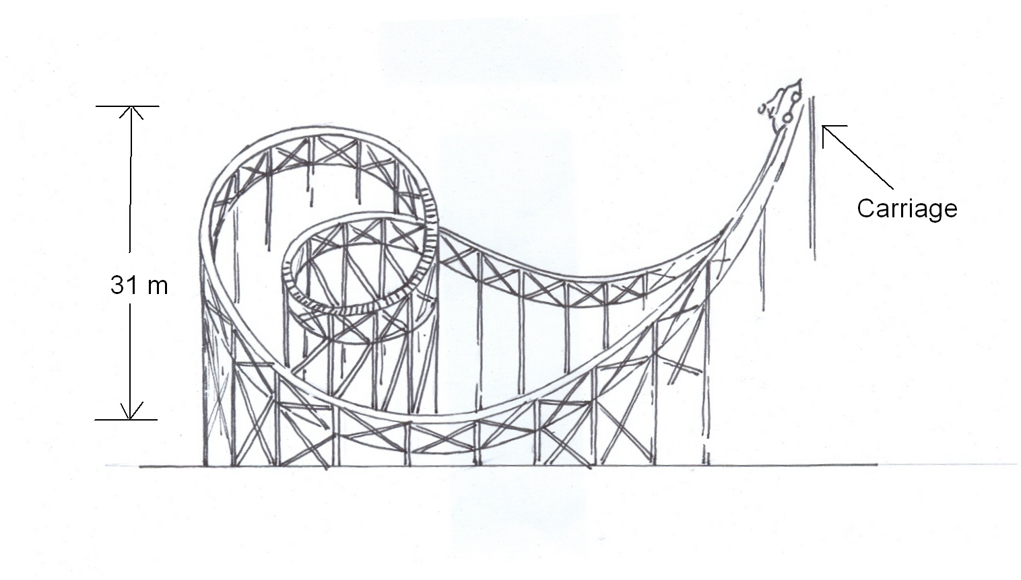
31.0m
360º loop
a) Calculate the potential energy of the carriage at the beginning of the ride.
[2 marks]

b) The car is then released and goes down a slope that is 70.0 m long, where the average frictional force is 30.0 N. What is the speed of the carriage when it reaches the bottom? [4 marks]

c) Calculate the momentum of the carriage at the bottom of the slope. [2 marks]

d) The diagram shows a 360º loop on the ride that is lower in height to the beginning of the ride, where the carriage was released. Briefly explain why this is necessary. [2 marks]

END OF SECTION 2
Section Three: Comprehension 12% (15 Marks)
This section contains one (1) question. You must answer this question. Write your answers in the spaces provided. You are reminded of the need for clear and concise presentation of answers. Diagrams (sketches), equations and /or numerical results should be included as appropriate.
Suggested working time: 25 minutes.
_________________________________________________________________________
18. Sudden Stop

(Paragraph 1)
Vehicles are not intrinsically dangerous: let's face it, you are most unlikely to have an accident if your car never leaves your driveway. Which tends to prove that it is the movement that causes all the problems. You see, as soon as your vehicle moves it comes under the influence of a variety of physical forces, some good for you, some bad. Things like momentum, kinetic energy, centripetal force, gravity, drag, directional force, etc.

(Paragraph 2)
The worst of that lot is kinetic energy, a function of the speed and loaded mass of the vehicle. This kinetic energy increases proportionally with the square of your speed. In other words, when you triple your speed (for example when you go from 30 km h⁻¹ to 90 km h⁻¹) your kinetic energy increases 9 times (3x3). This is not good because your braking distance will increase 9 times when you increase your speed 3 times. (Please note that I am not talking about the total stopping distance, as this would include the driver's thinking distance).

(Paragraph 3)
You probably realise what this means in practical terms: if you hit at 90 km/h the crash is going to be 9 times worse than it would be at 30 km/h. However if you take this a bit further, you will see that something good comes out of it. If faced with any crisis, wipe as much speed off the car as you can. So, you see that firstly (before taking evasive action with the steering wheel), you have to decrease your speed as much as you can - without locking the wheels - and then you must try to avoid a hard landing. Given a choice, a clump of bushes is preferable to a parked car, and hitting the back of a parked car at 60 km h⁻¹ will be pretty much the same as hitting a brick wall at half that speed.

(Paragraph 4)
Above all, never hit a tree!! Trees are the most unforgiving things that you may come up against in anger. There is no "give" in them and you concentrate the whole force on a narrow profile. And of course, make sure that your loads are secure, the baby is in the baby capsule on the back seat, and you and your passengers are all correctly buckled in.

Questions
1. Explain why the sudden stop in the collision is a killer. (3 marks)

2. Verify the claim that the "stopping distance increases 9 times when the speed increases 3 times". (Assume that the braking force is constant.) (2 marks)

3. What does "driver thinking time" have to do with the total stopping distance in a collision? (2 marks)

4. Why is hitting the back of a parked car at 60 km h ⁻¹similar to hitting a brick wall at half the speed? (3 marks)

5. Explain the Physics behind the claim that loads should be secured in a moving vehicle. Is this the same reasoning behind the wearing seat belts for people? (3 marks)

6. Explain how design features such as “crumple zones” use the concept of impulse to reduce the severity of injury to drivers in the event of a collision. (4 marks)

END OF EXAMINATION
Additional working space
Additional working space
Additional working space

